FIVE RULES FOR EFFECTIVE UI DESIGN ON SMALL SCREENS
- 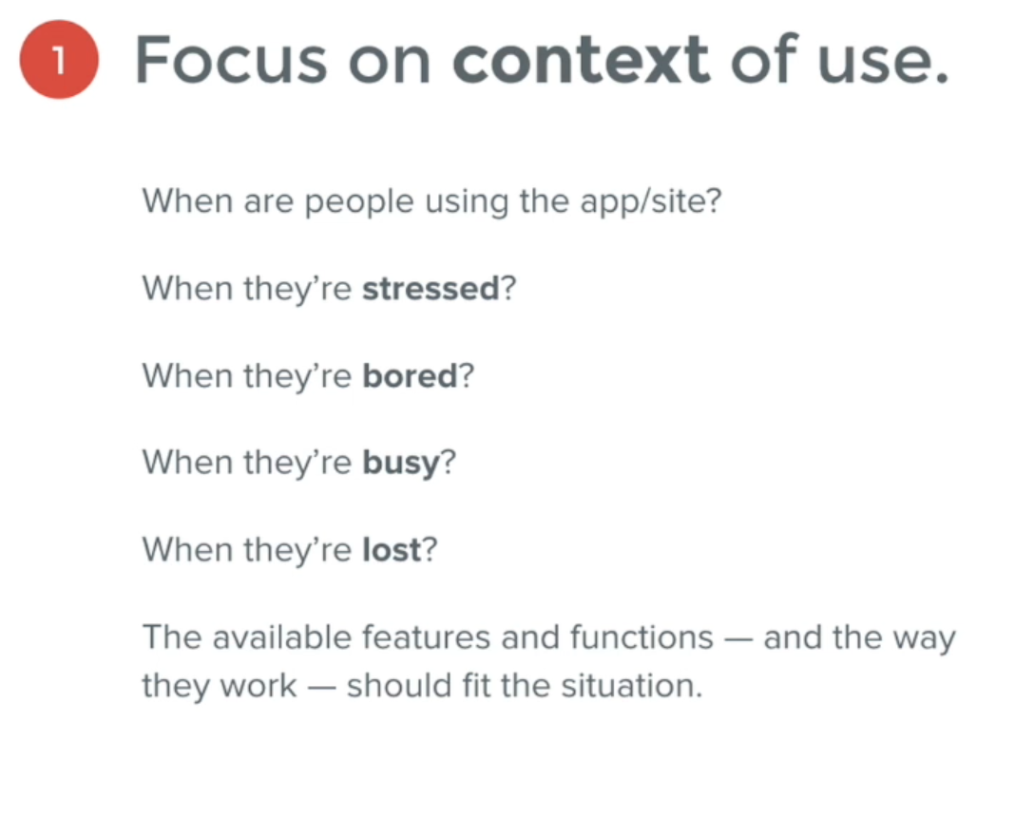
- 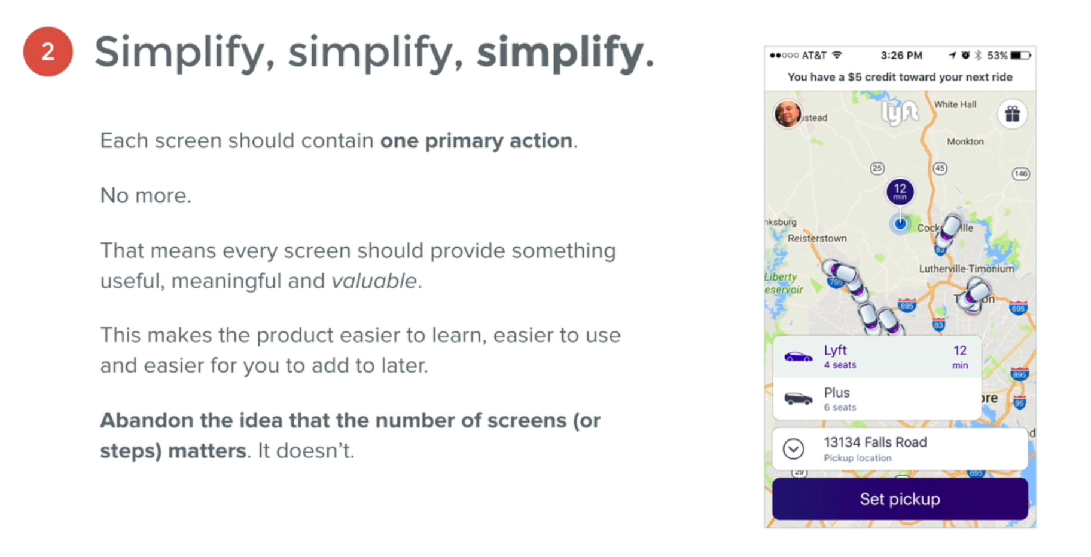
- people will type, tap, and swipe a million times so far it provides them with a result they value, so don’t limit yourself to initial engagement, but try to draw continuous engagement
- the design by the right has too many ambiguous things, as the user has to work to inteprete the meaning of things on the screen

